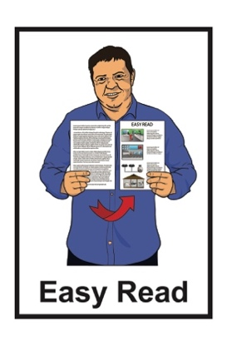

Hate crime laws review:

Information sheet –  
Making a submission



Published: February 2025

# Before you start



This information may upset some people when they are reading it.

If you are upset after reading this document you can talk to your:

whānau / family

friends.

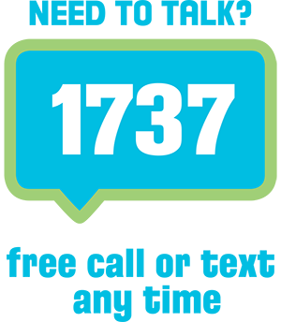You can also contact Need to Talk by:

calling 1737

texting 1737



It does not cost any money to call / text 1737.

This is a long document.

It can be hard for some people to read a document this long.

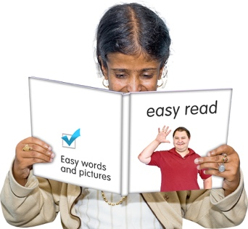Some things you can do to make it easier are:

read it a few pages at a time

set aside some quiet time to look 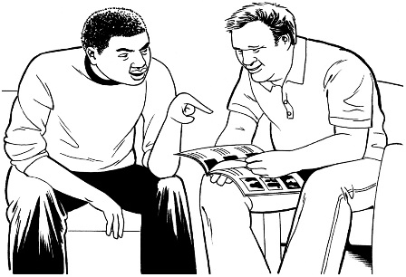at it

have someone read it with you to support you to understand it.

# What you will find in here

**Page number:**

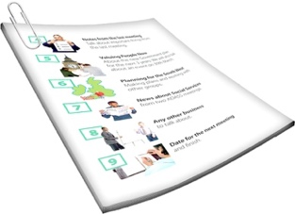About this information sheet 5

What is a submission? 12



How to make a submission 14

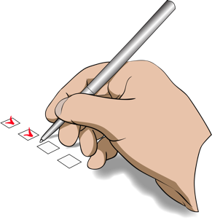

[What happens when we  
get your submission? 18](#Whathappenswhenwegetyoursubmission)

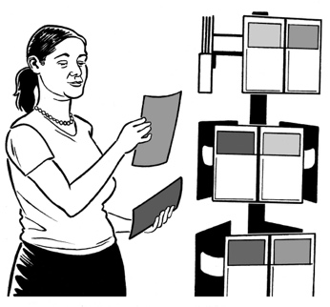

Official information 21

**Page number:**

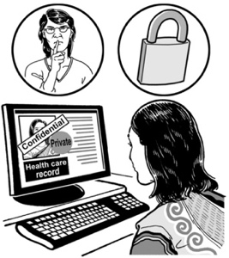

The Privacy Act 23

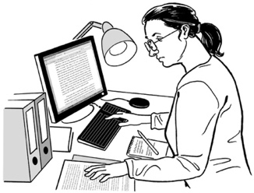

More information 24

# About this information sheet

This Easy Read document is from **Te Aka Matua o te Ture Law Commission**.

In this document we will call Te Aka Matua o te Ture Law Commission the **Law Commission**.

Where it says **we** / **our** this means the Law Commission.



The **Law Commission** does **research** to find out how to make better **laws**.

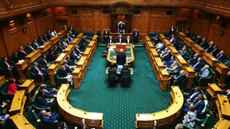It makes **recommendations** to the Government.

The Government cannot tell it what to do.



**Laws** are rules made by the Government which people must follow.

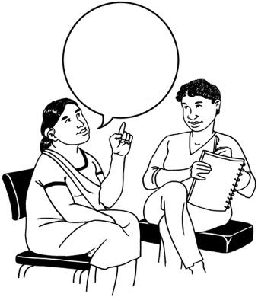

Making **recommendations** means telling someone what we think they should do to make things better.



We are doing a **review** of the laws about **hate crimes**.

Here **review** means looking at:

* how well something is working
* if anything should change.

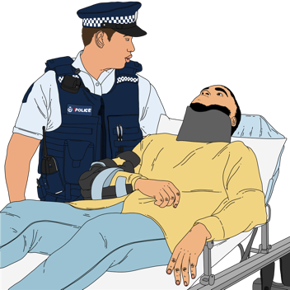

**Hate crime** is when the reason for a crime is hate.

We want to find out what people think needs to happen about hate crime laws.

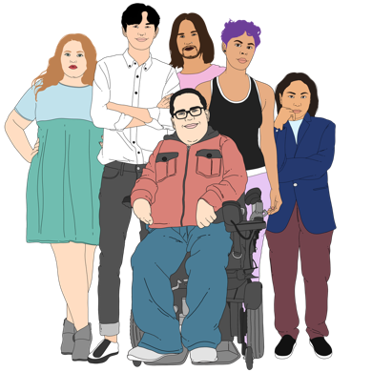We are **publicly consulting** about the review now.

**Publicly consulting** means giving everyone a chance to tell the Law Commission what they think.

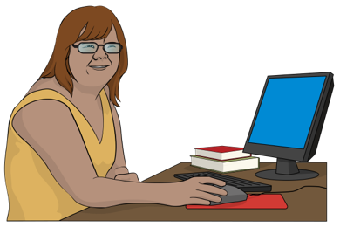We have made a document to support people to do this.



It is called the Consultation Paper.



We have also made a **summary** of the Consultation Paper.

A **summary:**

* is shorter than the main document
* tells you the main ideas.

This document is called the Information Sheet.

The Information Sheet is 1 of 4 documents making up the Easy Read summary of the Consultation Paper

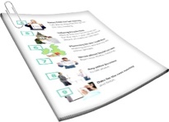

It lets you know how to tell us what you think about hate crime laws in   
Aotearoa New Zealand.

The 4 parts to the Easy Read summary are:

this Information Sheet

**Part 1** whichtells you about hate crime laws and this review

* **Part 2** whichtells you about the problems with the hate crime laws

**Part 3** whichis about:

* things to think about to do with the hate crime laws
* if you think hate crime laws should be changed.

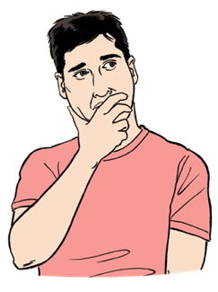We want to know if you think the laws about hate crimes:

* are working
* can be made better
* 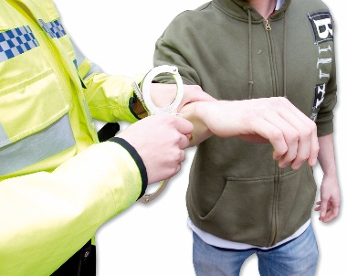should be changed to treat hate crimes more seriously

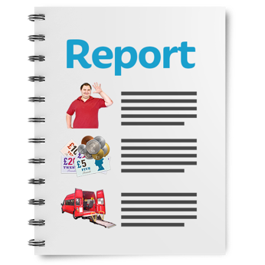

When we have finished the review we will write a report about what we find out.



We will give the report to the Government in 2026.

You can read the Consultation Papers here:

full Consulation Paper

****[**https://bit.ly/412iZyH**](https://bit.ly/412iZyH)

* summary Consultation Paper.

[**https://bit.ly/40Z0XP0**](https://bit.ly/40Z0XP0)

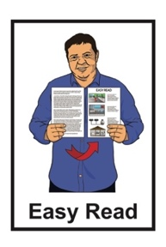

These 2 documents are not in   
Easy Read.

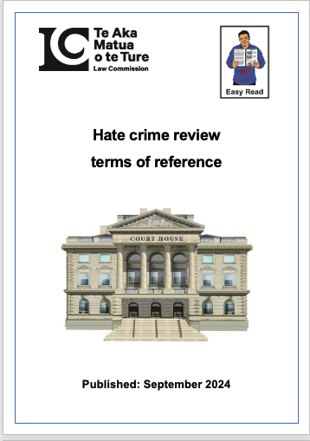You can also find out more about our review by reading the hate crime review Terms of Reference at:

**www.lawcom.govt.nz/our-work/hate-crime/tab/terms-of-reference**

# What is a submission?



Here a **submission** means the way you can tell us what you think about the hate crime laws.



We want to hear what you think about hate crime laws in Aotearoa / New Zealand.

Making a submission about this will support us to:

* write our report about hate crime laws in Aotearoa New Zealand
* ****make recommendations to the Government about how to make hate crime laws better.

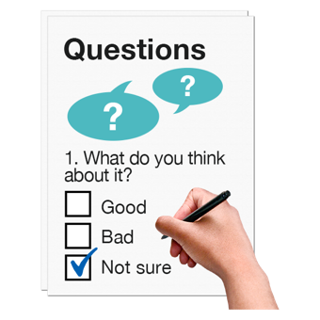There are some questions about hate crime laws in the other 3 Easy Read documents.



These questions will support you to think about the hate crime laws.

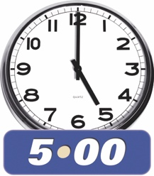You need to send your submission to the Law Commission by:

**5pm**

**13 March 2025**

# How to make your submission

You can:

* fill out a submission form on our **website**

**www.lawcom.govt.nz/our-work/hate-crime**

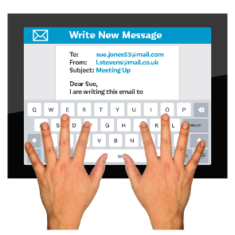**email** us at:

[**hate.crime@lawcom.govt.nz**](mailto:hate.crime@lawcom.govt.nz)

* 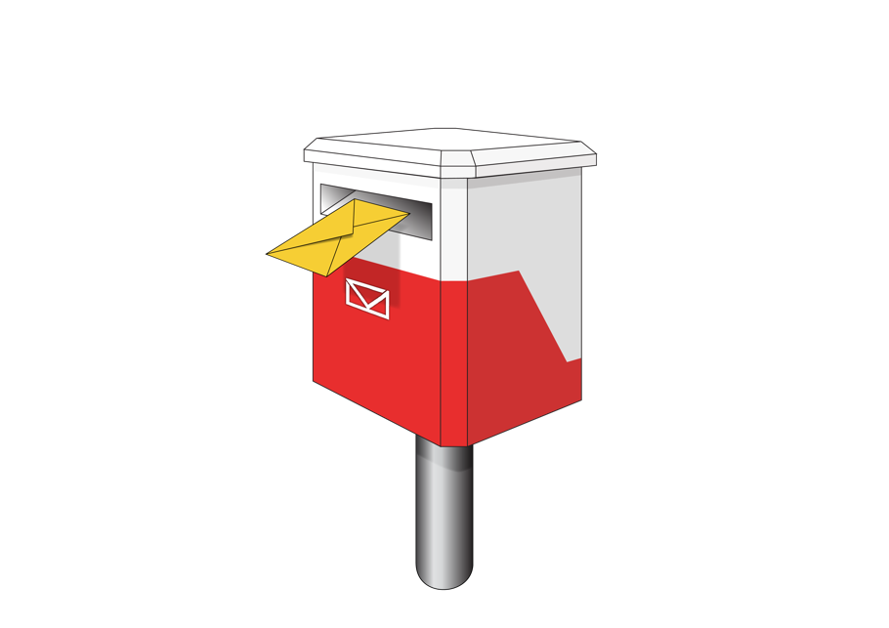**write** to us at:

Hate crime

Law Commission

PO Box 2590

Wellington 6140

****If you need to make your submission in a different way you can:

* **email** us and tell us how we can support you

[**hate.crime@lawcom.govt.nz**](mailto:hate.crime@lawcom.govt.nz)

**or**

* **call** us:

**0800 832 526**

If you find it hard to use the phone the **New Zealand Relay** service is for people who are:

* Deaf / hard of hearing
* deafblind
* speech impaired / find it hard to talk.

You can find out more about the New Zealand Relay service at:

**www.nzrelay.co.nz**



Some people may find it upsetting to make a submission about hate crime laws.

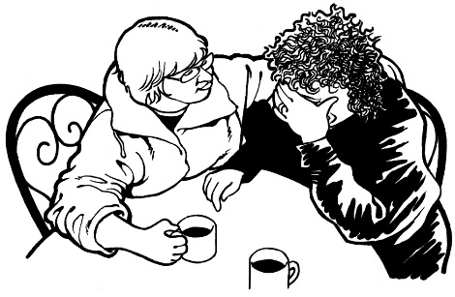

You can have a person you trust to support you to make your submission.



You can also call / text 1737 to talk to a trained **counsellor**.

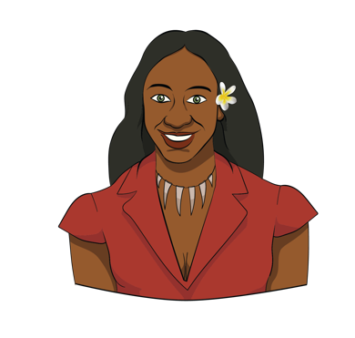

Here a **counsellor** is someone trained to support somebody to feel safe when they are talking about something hard to talk about.

The counselling service is provided by Whakarongorau Aotearoa / New Zealand Telehealth Services.

# What happens when we get your submission?

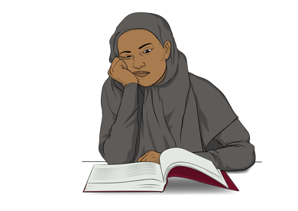

When we get your submission we will:

* read it carefully
* think about how your submission can support our review
* keep your submission as an **official record**.

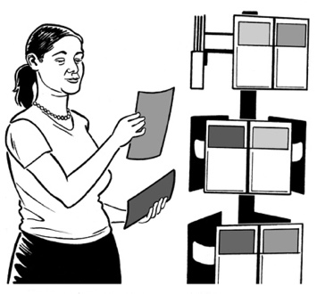

Here an **official record** means all the documents we have / receive about hate crime laws like your submission.

We may also:

* talk about your submission in our documents about the hate crime laws review
* put your submission on our website



* use your submission to support us with other work we are doing.



You need to tell us if you do not want us to **publish**:

* 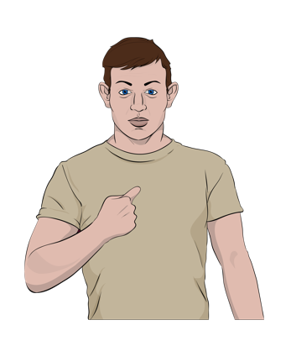your name

any information that may let somebody know who you are

some parts of your submission.

Here **publish** means making information available to everybody by publishing it:

on websites

in books / newspapers / magazines.



We will publish all the information in your submission unless you tell us not to.



We will only use your submission in our work about hate crime laws.

# Official information



The information held by the Law Commission is called **official information**.

**Official information** is information a:

Government agency has

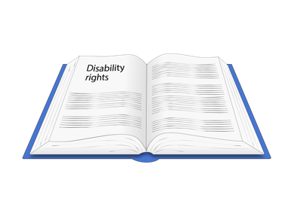Government Minister has.

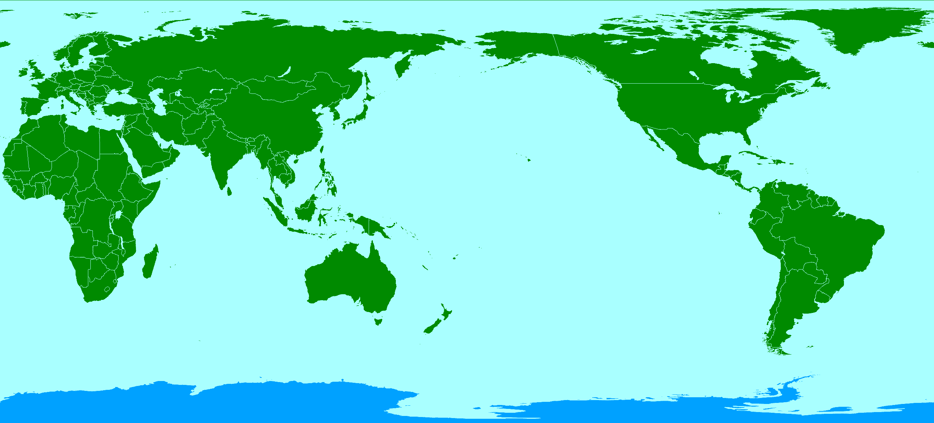You can ask for official information.

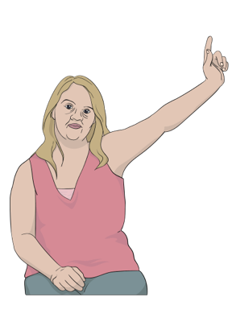

Somebody may ask for official information that could include your submission.

Before we give your submission to somebody we will:

* think about giving it to the person who has asked for it
* find out if you have told us there is information in your submission you do not want to be published
* try to talk to you about what is happening.

# The Privacy Act 2020

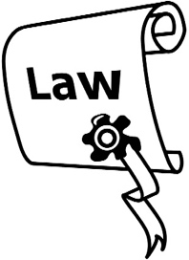

There is a law to protect your **privacy** called the Privacy Act.

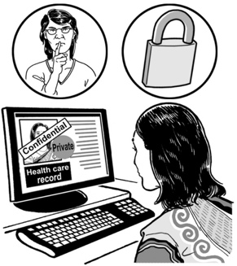

Here **privacy** means keeping information about you safe.

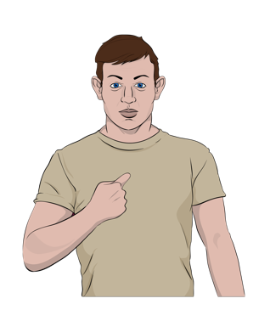

Your submission may include information about you.



You can ask the Law Commission about any information we may have about you.

This can include information about you in your submission.

# More information



You can find out more information on the Law Commission **website** at:

[**www.lawcom.govt.nz**](http://www.lawcom.govt.nz)

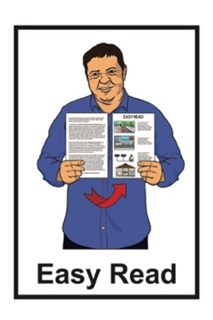

The website is **not** in Easy Read.

This information has been written by Te Aka Matua o te Ture Law Commission.

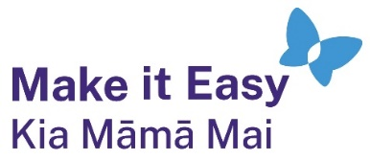It has been translated into Easy Read by the Make it Easy Kia Māmā Mai service of People First New Zealand Ngā Tāngata Tuatahi.



The ideas in this document are not the ideas of People First New Zealand Ngā Tāngata Tuatahi.



All images used in this Easy Read document are subject to copyright rules and cannot be used without permission.

Make it Easy uses images from:

* Photosymbols
* Change Images
* Huriana Kopeke-Te Aho
* SGC Image Works
* A logo for a school

  Description automatically generatedT Wood
* Studio Rebeko.