
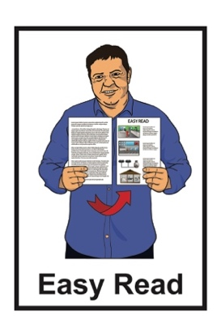

Hate crime laws review:

Part 1 –
Consultation Paper summary
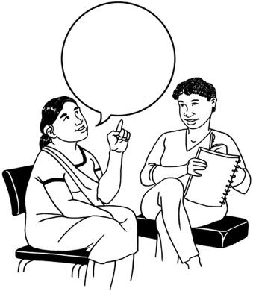
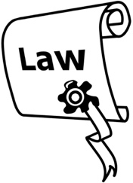

Published: February 2025

Before you start
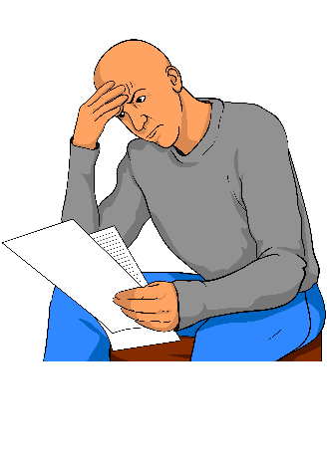

This information may upset some people when they are reading it.


If you are upset after reading this document you can talk to your:
whānau / family
friends.

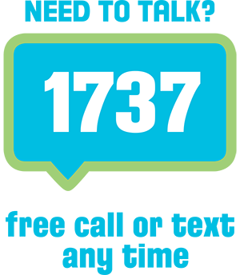
You can also contact Need to Talk by:
calling 1737


texting 1737

It does not cost any money to call / text 1737.

This is a long document.

It can be hard for some people to read a document this long.

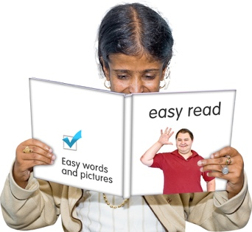
Some things you can do to make it easier are:
read it a few pages at a time
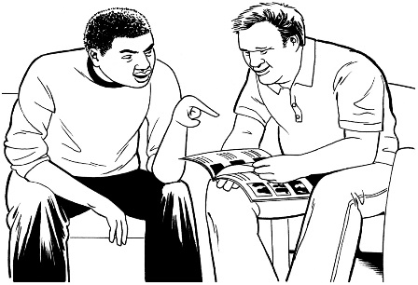
set aside some quiet time to look at it
have someone read it with you to support you to understand it.

What you will find in here

Page number:

About this document 4


About hate crimes 10


About the review 14

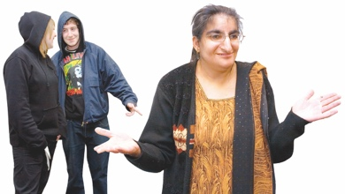
How hate crimes affect people 20


Key things to think about 23

Questions 35


More information 40

About this document

This Easy Read document is from Te Aka Matua o te Ture Law Commission.


In this document we will call Te Aka Matua o te Ture Law Commission the Law Commission.

Where it says we / our this means the Law Commission.



The Law Commission does research to find out how to make the laws better here in Aotearoa
New Zealand.

We are doing a review about hate crime laws.

Here review means looking at:
- how well something is working
- if anything should change.

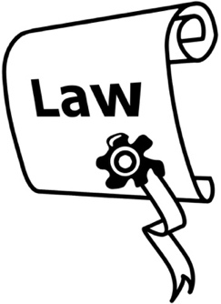
Laws are rules made by the Government which people must follow.


We want to find out what people think about hate crime laws here in Aotearoa New Zealand.


We have made a document to support people to do this.

It is called the Consultation Paper.


We have also made a summary of the Consultation Paper.

A summary:
- is shorter than the main document
- tells you the main ideas.


This document is called Part 1.

Part 1 is 1 of 4 documents making up the Easy Read summary of the Consultation Paper.

It tells you about hate crime laws and this review.

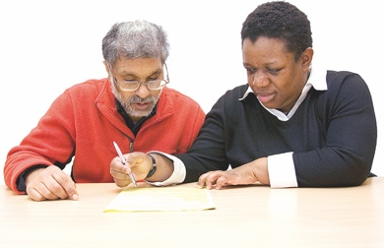
These 4 Easy Read documents will support you to make a submission.


Here a submission means the way you can tell us what you think about the hate crime laws in Aotearoa
New Zealand.


Your submissions will help us to work out what needs to change about hate crime laws.
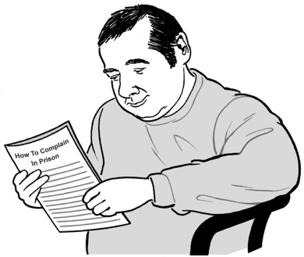

All 4 Easy Read documents have important information that will be useful when you make a submission.

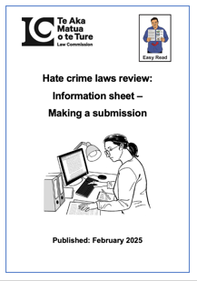
The Information Sheet tells you what you need to know including:
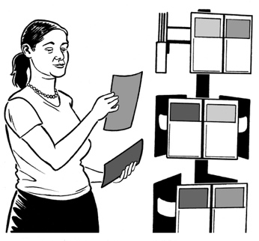
- how to make your submission
- information about your privacy
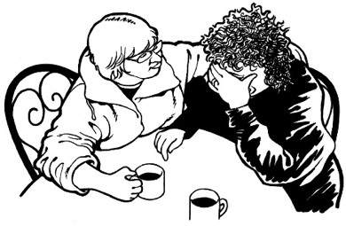
- how we will use the information you give us in your submission
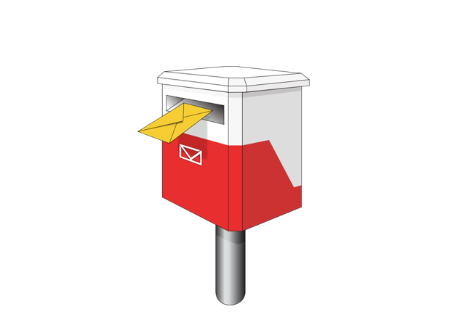
where to get support if you find making a submission about hate crime laws upsetting
- where to send your submission
- links to the other information about the hate crime laws review.

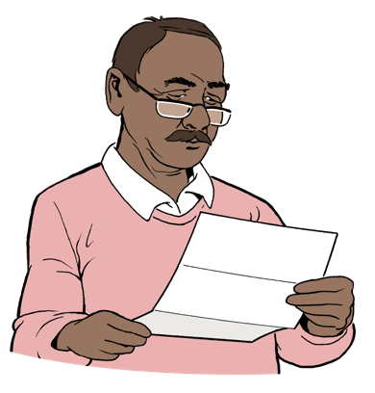
Read the Easy Read terms of reference for this review here:

www.lawcom.govt.nz/our-work/hate-crime/tab/terms-of-reference

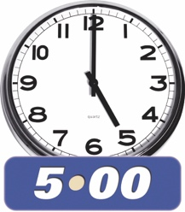
You need to send your submission to the Law Commission by:
5pm

13 March 2025

About hate crimes

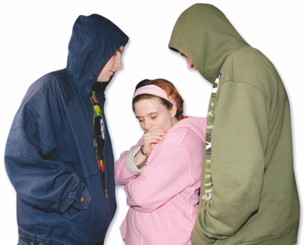
A crime is when someone:
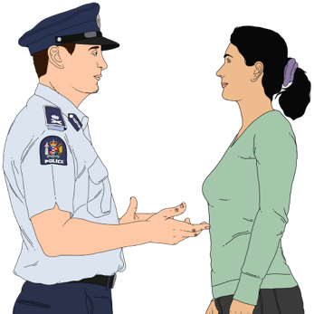
does something wrong that harms others
- breaks the law.

A hate crime is when someone commits a crime because of hate towards a group of people who have a common characteristic.



Characteristics are things a person / group have in common.

They can be things like:
race / skin colour
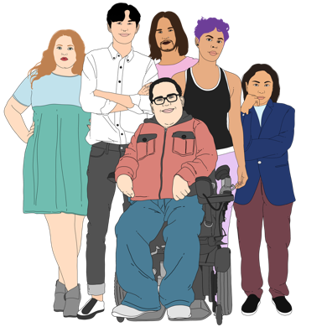
religion
gender
sexuality
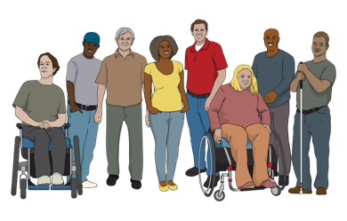
- age
- disability.

Gender is if you are:
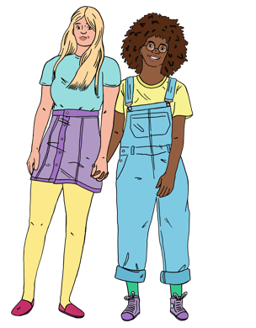
a man
a woman
another gender like nonbinary.

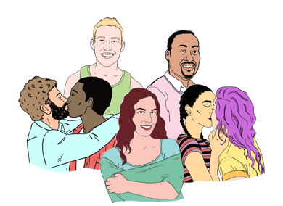
Your sexuality is things like:
who you are attracted to
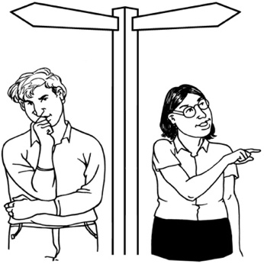
who you want to be in a relationship with
if you want to be in a relationship or not.

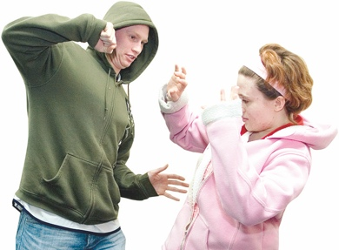
Examples of hate crimes might be:
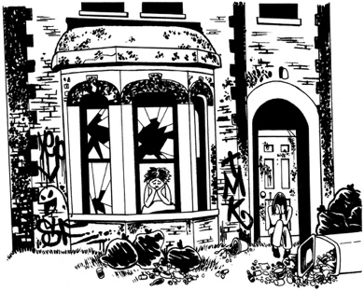
someone hitting you because you are disabled
someone damaging your house because you are gay.

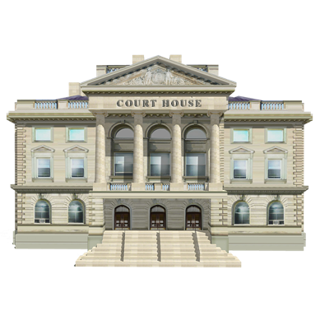
If a crime is seen as a hate crime it changes the sentence the court can give.

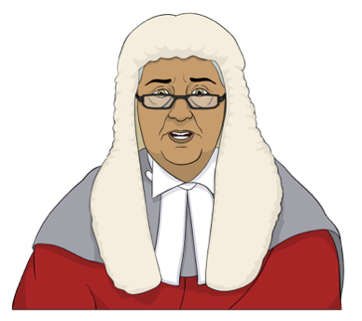
It can make the sentence higher / bigger.

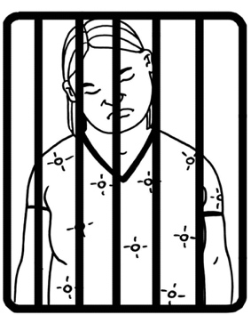
Sentence means what a judge says should happen to someone who has committed a crime / offence like:
going to prison
paying a fine / money.

About the review


On 15 March 2019 a man with a gun shot a lot of people in 2 masjidain / mosques in Christchurch.


There was a Royal Commission of Inquiry to find out:
how this could have happened
how to stop it happening again.


A Royal Commission of Inquiry is a way for the Government to look into important issues.

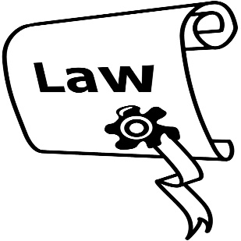
The Royal Commission of Inquiry said Aotearoa New Zealand should change the law so that hate crimes are treated more seriously.


Our review will look at the laws about hate crimes to find out if they:
are working
should be changed to treat hate crimes more seriously.


The review will also look at if there are more crimes that should be treated as hate crimes.

The review might also look at:

what hate crimes should be treated more seriously
- which groups of people should be protected
- what the maximum sentence should be.

Protected means kept safe.


Maximum means the most / biggest that something could be.


Our review will not look at making anything that is not already a crime into a crime.


This means our review will not look at things like:
videos people might find upsetting
hate speech.
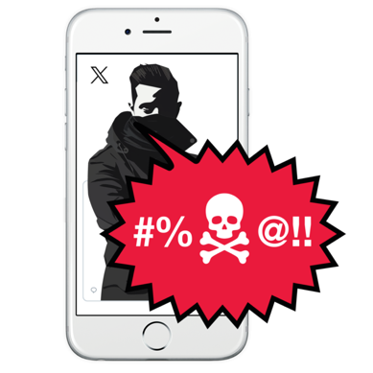

Hate speech means saying things that could stir up hate against a group of people.

The reason the Law Commission has made the Consultation Papers is:
- so that we can hear from people
and
- because they can tell us about what they think about hate crime laws in Aotearoa New Zealand.
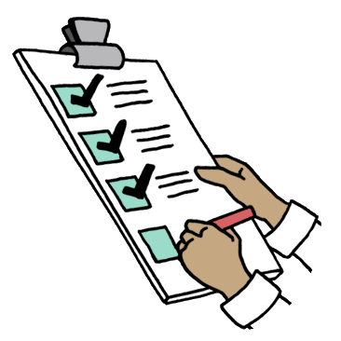

The submissions will support us to make recommendations to the Government about hate crime laws.

Making recommendations means telling someone what we think they should do to make things better.

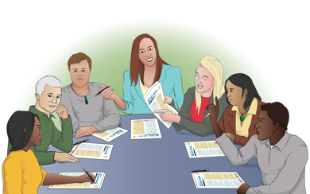
We will also talk to experts about the changes we think should be made.


We plan to report to the Minister of Justice in 2026.

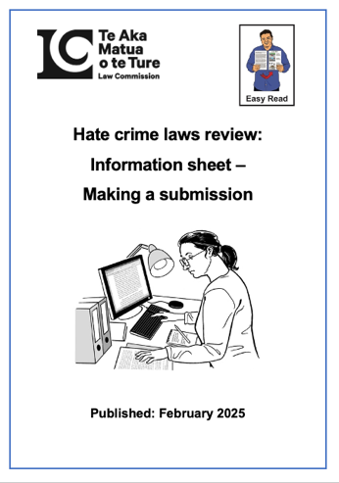
You can find out more information in the Information Sheet:

https://bit.ly/3Ej94Nj

How hate crimes affect people


A hate crime is when someone
uses hate to target a part of who you are.


This hurts the:
- victim

and
- community the victim belongs to.
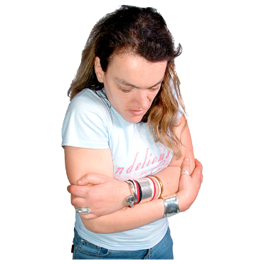

It makes people feel less connected to each other.


We do not know a lot about hate crime in Aotearoa New Zealand.

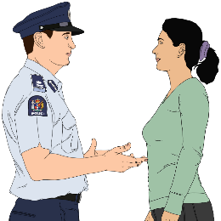
Ngā Pirihimana o Aotearoa / New Zealand Police have collected information from people who report what they think is a hate crime.


We call Ngā Pirihimana o Aotearoa / New Zealand Police the Police for short.


There were 5 thousand and 19 reports of hate crime to the Police in 2023.

The hate crimes reported were about things like:
- a person / group trying to hurt / hurting another person
- a person / group damaging property.

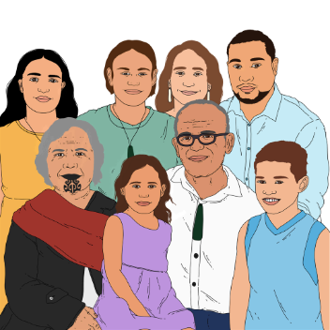
People were being hurt because of their characteristics like:
- race

- ethnicity
- religion
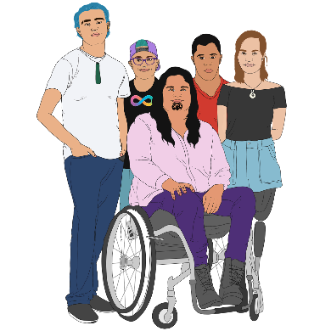
- sexual orientation
- gender identity.


Only some of the hate crimes reported could be looked into by the Police.

The Police did not have enough information to look into all the reported hate crimes.

Key things to think about


Here key means the most important things to think / talk about.

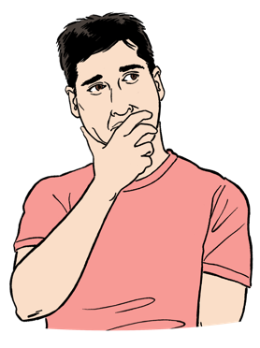
There are some key things we need to think about during the review on hate crime laws.

1. Why are hate crimes treated more seriously than other crimes?


Hate crime laws treat hate crime more seriously than other offending.

Here offending means breaking the law.

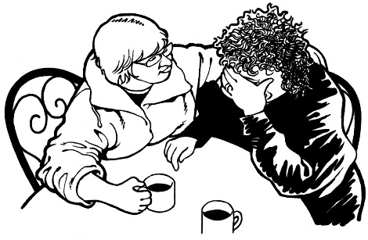
The reasons for this include:
- hate crimes cause more harm than some other crimes
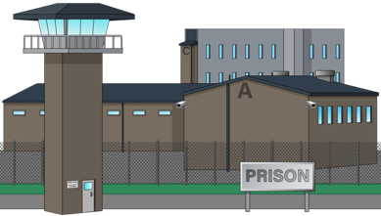
- the law needs to tell people that hate crimes are very serious
- people doing hate crimes need to be punished in a way that they will stop doing hate crimes.
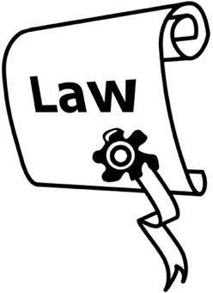

We want to find out if the hate crime laws in Aotearoa New Zealand treat hate crimes seriously enough.


2. Are there good reasons to make new hate crime offences?

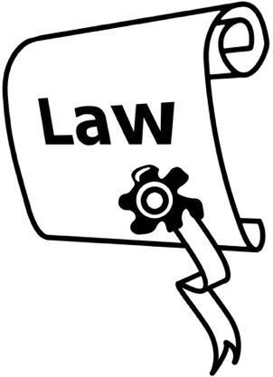
An offence is when someone has:

done something bad
and
broken the law.

An offence is also called a crime.

A person who commits / does an offence is called an offender.

The Law Commission review wants to find out if making new hate crime offences is the right thing to do.


There needs to be a very good reason to make new offences.

Ngā Tikanga


We will remember that Te Ao Māori is important when we are doing the review.

Te ao Māori means the Māori world.
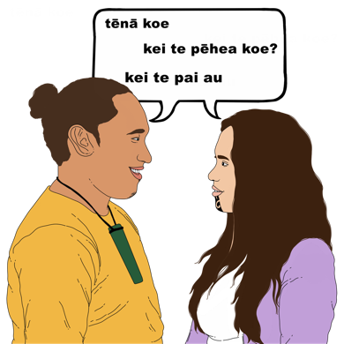

It includes things like:
language
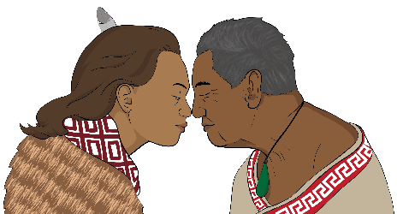
beliefs
ngā tikanga.

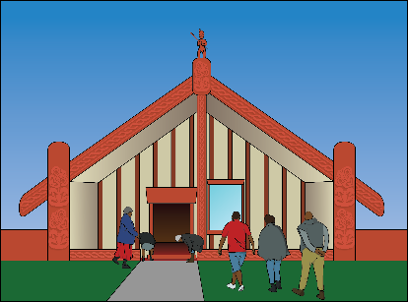
Ngā Tikanga are Māori ways of doing things.

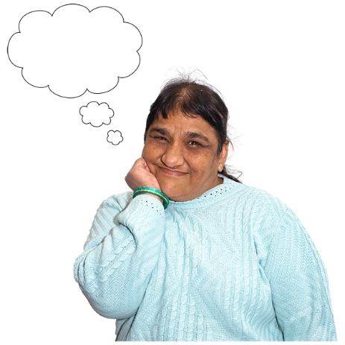
There are 3 tikanga that help us think about hate crime in Te Ao Māori:
- hara
- kanga
- kōruhu.

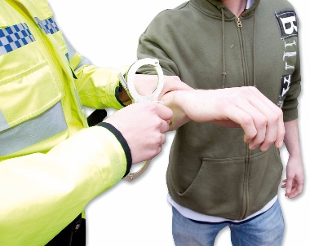
Hara means that someone has done something that breaks a law.

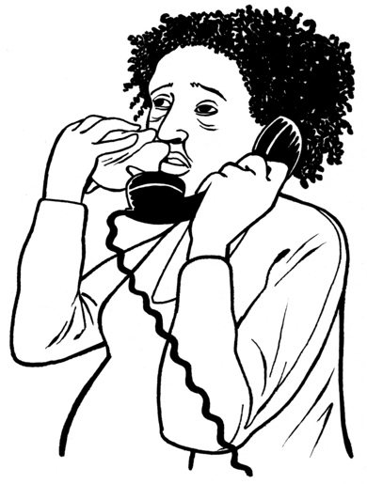
Kanga is serious hara.

It can be something like saying a very hurtful thing to a person / group.

Kōruhu is serious hara.
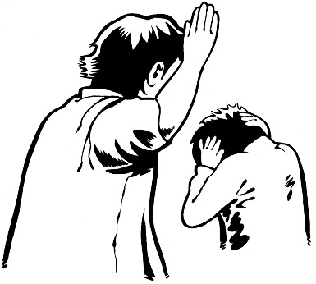

It can be when somebody does:

- something very bad to another person / group
and
- does not feel bad about doing it.
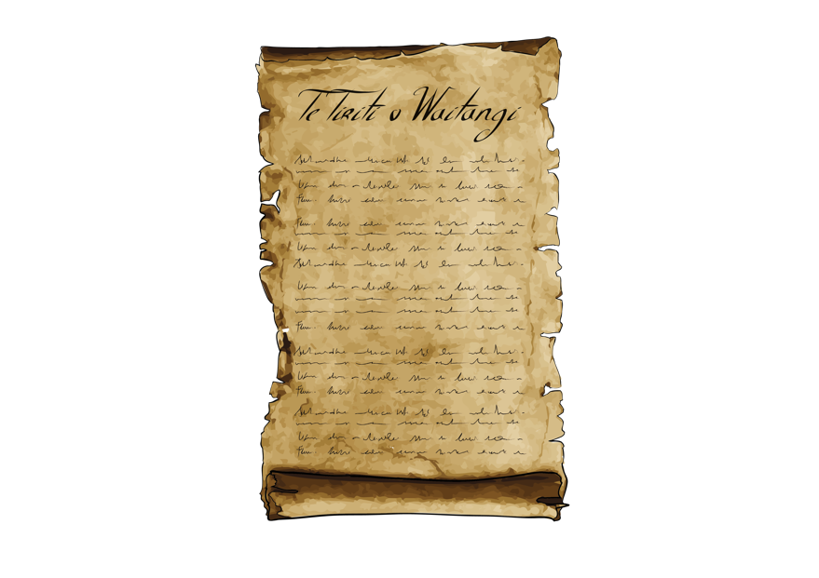

4. Te Tiriti o Waitangi / Treaty of Waitangi

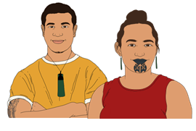
Te Tiriti o Waitangi / Treaty of Waitangi is an important agreement between:
Māori

and
the Crown.
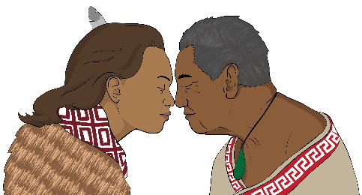
Te Tiriti is an important document in Aotearoa New Zealand.

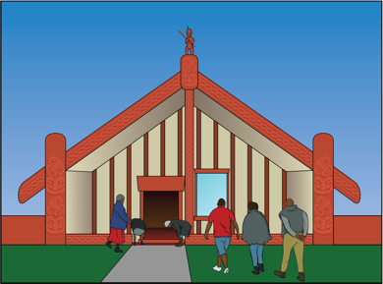
As we work on our review we need to think about Te Tiriti.

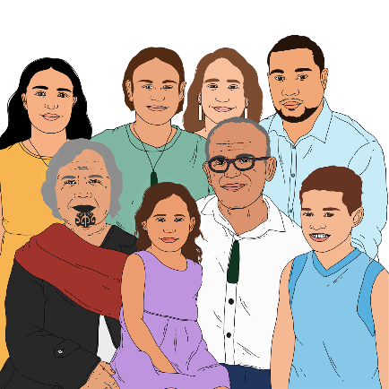
This means we will need to:
- include Māori communities in this work
- think about if hate crime law is fair to Māori.

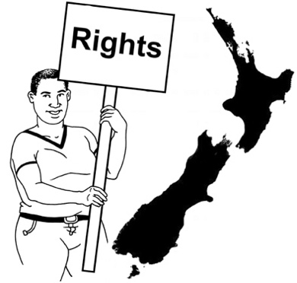
5. Human rights


Human rights are things that everyone needs to be able to live a good life like:
- having a safe place to live
- being able to think / say what you want to think / say
- being free from harm.


Some people think making hate crime laws stronger will make sure people get their human rights.

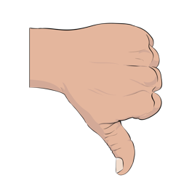
Some other people think making hate crime laws stronger will mean some people will not get their human rights.

The review will think about how making hate crime laws stronger will:
- support human rights
- hurt human rights.


6. What characteristics should be protected by hate crime laws?

We are thinking about what characteristics:

- are already protected by laws

- should be included in hate crime laws.

Finding this out will help us decide if:
- any changes need to be made to the hate crime laws
and
- what these changes will be.

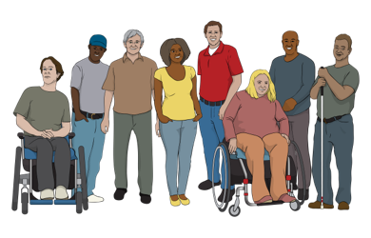
Things we will need to think about include:
- how badly a group of people is hurt by hate crimes
- what kind of hate crimes are happening against a group of people
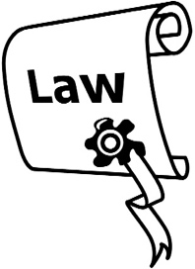
- is a hate crime law the best way to deal with the offending.

Here offending means when:
someone does something bad to a person / a group
and
it breaks the law.


We will also look at what other countries are doing with their hate crime laws.

Some people do not think hate crime law is the best way to protect some groups of people from harm.

We will have to think about which characteristics should be protected / included in the laws.

A protected characteristic is when a characteristic is already included in a law.

Questions

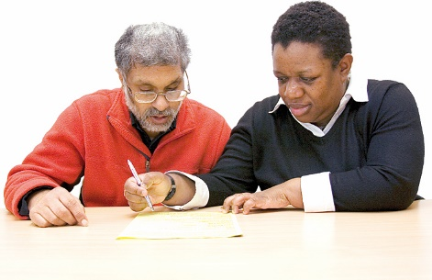
Write your answers to the questions in the boxes.

You do not have to answer all of the questions.

What kinds of hate crimes do you think are happening in Aotearoa
New Zealand?

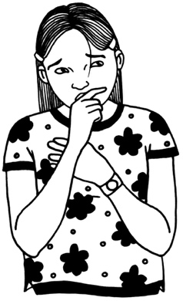
How do you think these hate crimes affect people?

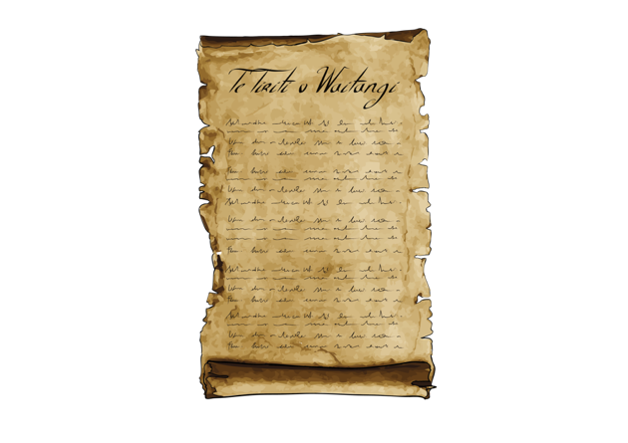
How can we do the best thing by
Te Tiriti when thinking about changing the hate crime laws?

What characteristics do you think should be protected by hate crime laws?



Why do you think this?

What do you think about the key things we are thinking about for our review on hate crime laws?

More information

You can find out more information on the Law Commission website at:

www.lawcom.govt.nz
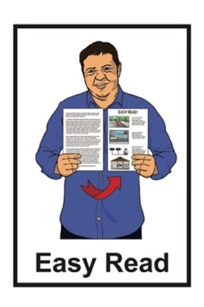

The website is not in Easy Read.

This information has been written by Te Aka Matua o te Ture Law Commission.


It has been translated into Easy Read by the Make it Easy Kia Māmā Mai service of People First New Zealand Ngā Tāngata Tuatahi.

The ideas in this document are not the ideas of People First New Zealand Ngā Tāngata Tuatahi.

All images used in this Easy Read document are subject to copyright rules and cannot be used without permission.


Make it Easy uses images from:


- Photosymbols

- Change Images



- Huriana Kopeke-Te Aho

- SGC Image Works


- T Wood

- Studio Rebeko.

