


Hate crime laws review:

Part 2 –
Consultation Paper summary


Published: February 2025

Before you start


This information may upset some people when they are reading it.


If you are upset after reading this document you can talk to your:
whānau / family
friends.


You can also contact Need to Talk by:
calling 1737


texting 1737

It does not cost any money to call / text 1737.

This is a long document.

It can be hard for some people to read a document this long.


Some things you can do to make it easier are:
read it a few pages at a time
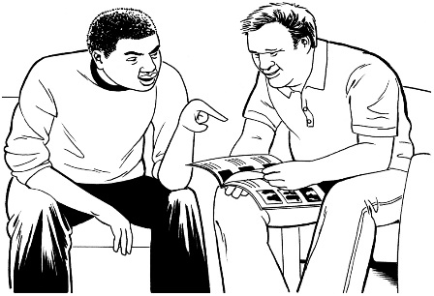
set aside some quiet time to look at it
have someone read it with you to support you to understand it.

What you will find in here

Page number:


About this document 5


Current hate crime laws 11


Are there problems with the
current hate crime laws? 18

Supporting people to report
hate crimes 22

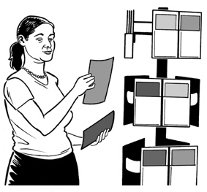
Getting information
about hate crimes 24

Page number:


Aggravating factors used
in hate crime laws 27


Rehabilitation 32

Questions 34


More information 36

About this document

This Easy Read document is from Te Aka Matua o te Ture Law Commission.


In this document we will call Te Aka Matua o te Ture Law Commission the Law Commission.

Where it says we / our this means the Law Commission.

The Law Commission does research to find out how to make the laws better here in Aotearoa
New Zealand.

We are doing a review about hate crime laws.


Here review means looking at:
- how well something is working
- if anything should change.
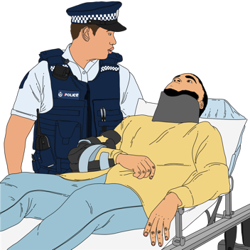

Hate crime is when the reason for a crime is hate.


Laws are rules made by the Government which people must follow.


We want to find out what people think about hate crime laws here in Aotearoa New Zealand.


We have made a document to support people to do this.

It is called the Consultation Paper.


We have also made a summary of the Consultation Paper.


A summary:
- is shorter than the main document
- tells you the main ideas.

This document is called Part 2.


Part 2 is 1 of 4 documents making up the Easy Read summary of the Consultation Paper.
It tells you about the problems with the hate crime laws.


These 4 Easy Read documents will support you to make a submission.


Here a submission means the way you can tell us what you think about the hate crime laws in Aotearoa
New Zealand.


Your submissions will help us to work out what needs to change about hate crime laws.

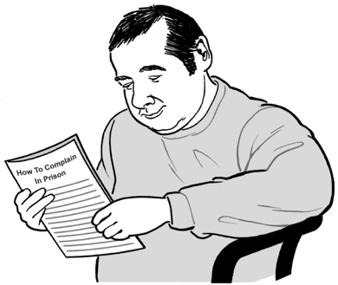
All 4 Easy Read documents have important information that will be useful when you make a submission.


The Information Sheet tells you what you need to know including:
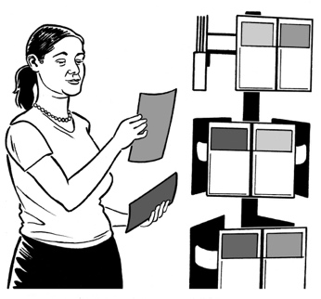
- how to make your submission
- information about your privacy
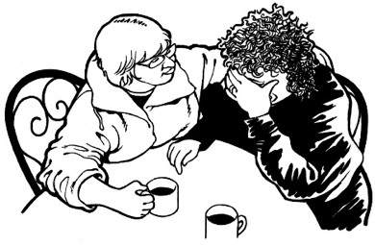
- how we will use the information you give us in your submission
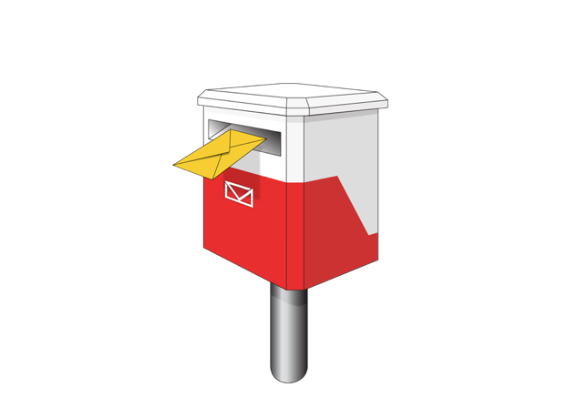
where to get support if you find making a submission about hate crime laws upsetting
- where to send your submission
- links to the other information about the hate crime laws review.

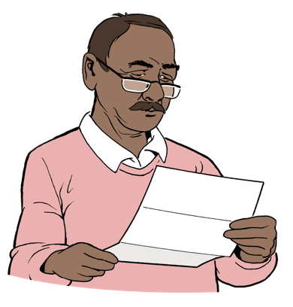
Read the Easy Read terms of reference for this review here:

www.lawcom.govt.nz/our-work/hate-crime/tab/terms-of-reference

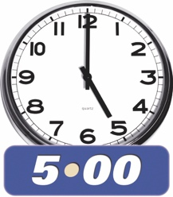
You need to send your submission to the Law Commission by:
5pm

13 March 2025

Current hate crime laws


Current hate crime law says the court can give an offender a longer / bigger sentence if they commit a hate crime.

Here current means what is happening now.


An offender means a person who commits / does an offence.



An offence is when someone has:
done something bad
and

broken the law.

An offence can also be called a crime.

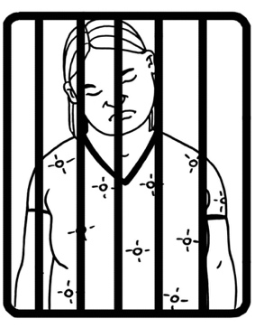
Here sentence means what a judge says should happen to someone who has committed a crime / offence like:
going to prison
paying a fine / money.


Hate crimes are committed because of hate towards group of people who have the same characteristics.


Here characteristics mean things a person / group have in common.


They can be things like:
race / skin colour
religion
gender
sexuality

- age
- disability.

Gender is if you are:
a man
a woman
another gender like nonbinary.

Your sexuality is things like:
who you are attracted to

who you want to be in a relationship with
if you want to be in a relationship or not.


The Royal Commission of Inquiry looked into the shooting of a lot of people in 2 mosques in Christchurch in 2019.


A Royal Commission of Inquiry is a way for the Government to look into important issues.


The shooting at the mosques was a very serious hate crime.

The Royal Commission of Inquiry said that the hate crime laws need to be:

- changed
and

- treated more seriously.

This is the reason why the Law Commission is looking into hate crime laws in Aotearoa New Zealand.

Read more about the reasons for the review in the Easy Read document called Part 1:

https://bit.ly/3CAGyGm


The sentencing act law says hate is an aggravating factor in a crime.

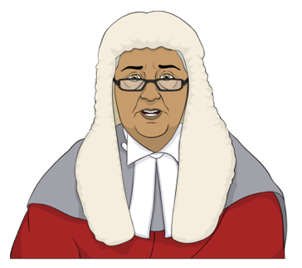
Here an aggravating factor means:
- it is included when a judge is making a decision about a crime
and
- can make the sentence longer.


Other things that can be seen as aggravating factors include when someone:
says they are going to hurt a person / group of people

hurts a person / group of people

uses a weapon like a knife to hurt a person / group of people.
is very cruel when they hurt a person / group of people

has hurt someone like a:
- child
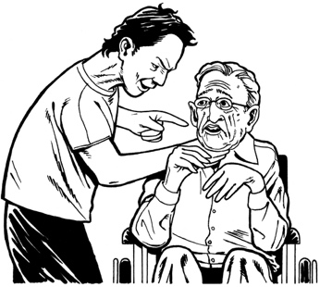
- older person.

Are there problems with the current laws?


Some people think that hate crime laws should send a message to say hate crime is a very serious wrong.

This can happen with the current law if:
- the judge says that the crime is a hate crime in the:

- court hearing

- in a written sentencing decision
- the media report the crime as a hate crime
- the offender gets a harder / longer sentence.
A court hearing is where a judge is given a lot of information about a case.

The judge:

- reads at all the information
and
- makes a decision about what
to do.


Here a case is about:
getting all the information together about a crime

deciding if the offender did the crime or not
deciding what sentences they should get if they did it.

A written sentencing decision is when the judge writes down:
what the sentence is they have decided on
and
the reasons why they made the decision.


Some people still think that the current law does not do enough to let people know about:
hate crimes

and
how serious hate crimes are.

They think this because:
hate motivation is not part of the crime the person is charged with
sentencing decisions do not have to say if hate motivation was the reason for a crime
courts do not have to make sentences harder / longer for hate crimes

the maximum sentence for a crime is the same even if the crime is a hate crime.


Here hate motivation means the reason for the crime is hate.

Maximum means the most / biggest that something could be.

Supporting people to report hate crimes



The Royal Commission of Inquiry found that hate crime is often not reported to the Police.

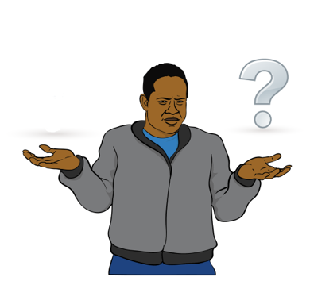
There are many reasons a person may not want to report hate crime.

These reasons can include because they:
- do not think the hate crime is serious enough to report to the Police
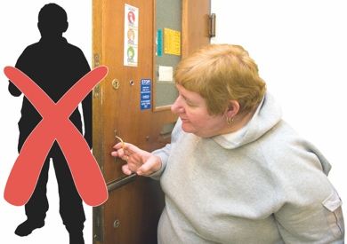
- do not know the offender
- have had bad experiences with the Police.
We would like to find out why people do not report hate crimes to the Police

The Police have started training police officers to treat reports of hate crime more seriously.

We would also like to find out if:

things have improved since this training has started
people feel like they can now report hate crimes to the Police.

Making sure hate motivation is included
in a crime

The Law Commission wants to find out if:
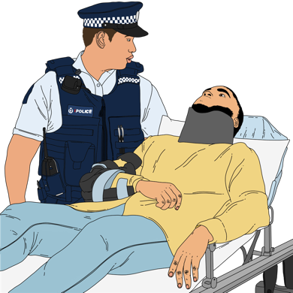
- Police treat all hate crimes seriously
- Police look into hate crimes in the right way
- the court is told about the hate crime when an offender is being sentenced
hate motivation should be included in other decisions made by the court.

Getting information about hate crimes

It is hard to get information about hate crimes.

This is because a hate motivation is not included as part of an offence.


This makes it hard to get information about hate crime that has been reported to Police.

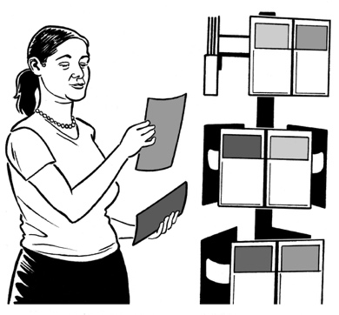
Police have made changes to improve how they record information about hate crimes.

Here records means keeping all the information the Police are given / have about hate crimes.
More hate crimes are now being reported each year.

More information is needed about:
- if an offender gets convicted of doing a hate crime
- what sentences offenders get when they do a hate crime
- if the court thinks about hate crime when deciding the sentence for an offender.

Here convicted means a judge says an offender has done a
crime / offence.

Aggravating factors used in the law

The Law Commission is thinking about how the aggravating factor is used in court decisions.

There are 3 main things we would like to know about.

1. Including an aggravating factor if hate / hostility is not the main reason for the crime.


Here hostility means treating somebody in a:
very unfriendly way
very bad way.


An aggravating factor can be included in a decision even if
hate / hostility is not the main reason for the crime.

We did not find any information to tell us if this has happened.

2. It may not be clear what things are common characteristics

The aggravating factor can only be included if the offending is against a group of people who share a common characteristic.

It may not always be clear what things are common characteristics.

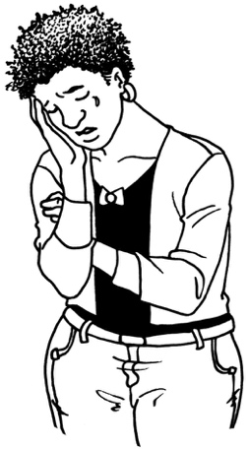
For example:
sex is a common characteristic for women
but
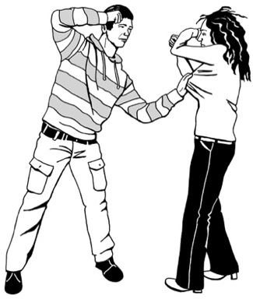
the aggravating factor is not used very much when there is a hate crime against a woman.

3. Aggravating factor is only used if the offender thinks the victim is from a group of people with a protected characteristic


A protected characteristic is when a characteristic is already included in a law.

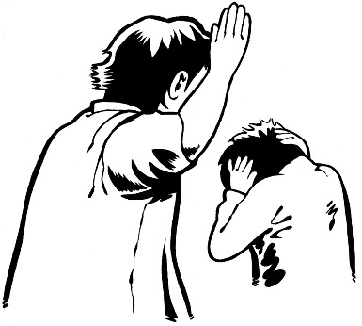
This means that the aggravating factor is only used if the offender:
- does a hate crime

and
- thinks the victim is part of a group of people who share a common characteristic that is included in law.

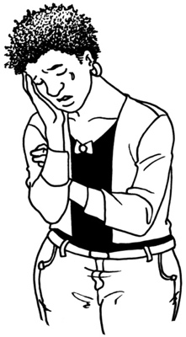
Here victim means the person / people who was / were hurt by the hate motivated crime.

For example the aggravating factor is not used:
if an offender writes hateful graffiti / words on a public property
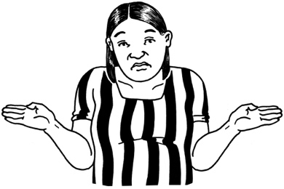
and
does not know who the owner of the building is.


Graffiti is when somebody:
- writes / draws on a something like a wall including by:
- spray painting / painting
- scratching
and
- they know that they are not allowed to do this.

Rehabilitation

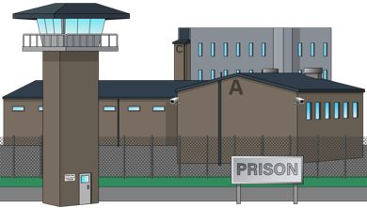
Here rehabilitation happens when an offender has been sentenced for a hate crime.

It can happen:

in prison
in the community.

If hate motivation is not included in the offence:

- Corrections may not know that hate was part of the reason for the offending
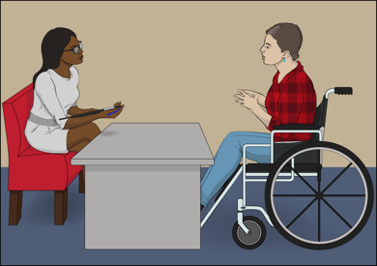
- Corrections may not be able to work with the offender to stop them doing hate crimes.
Ara Poutama Aotearoa / Department of Corrections looks after offenders who are sent to prison.

Ara Poutama Aotearoa / Department of Corrections is called Corrections for short.

Questions


Write your answers to the questions in the boxes.

You do not have to answer all the questions.

Do you think there are problems with how current hate crime law is working in Aotearoa New Zealand?

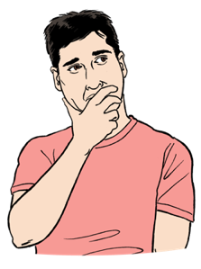
What do you think the problems are?

More information


You can find out more information on the Law Commission website at:

www.lawcom.govt.nz


The website is not in Easy Read.

This information has been written by Te Aka Matua o te Ture Law Commission.


It has been translated into Easy Read by the Make it Easy Kia Māmā Mai service of People First New Zealand Ngā Tāngata Tuatahi.

The ideas in this document are not the ideas of People First New Zealand Ngā Tāngata Tuatahi.

All images used in this Easy Read document are subject to copyright rules and cannot be used without permission.


Make it Easy uses images from:


- Photosymbols

- Change Images



- Huriana Kopeke-Te Aho

- SGC Image Works


- T Wood

- Studio Rebeko.

