


Hate crime laws review:

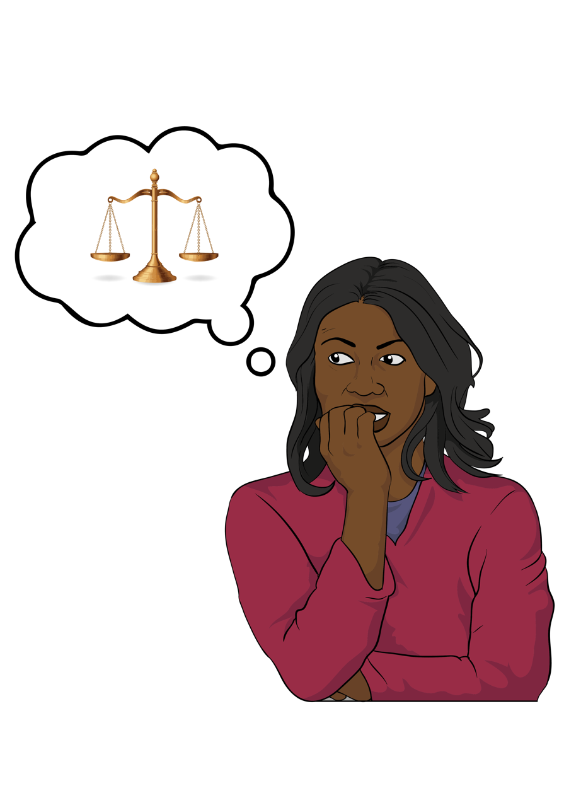
Part 3 –
Consultation Paper summary

Published: February 2025

Before you start


This information may upset some people when they are reading it.


If you are upset after reading this document you can talk to your:
whānau / family
friends.

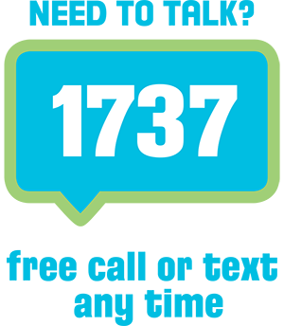
You can also contact Need to Talk by:
calling 1737


texting 1737

It does not cost any money to call / text 1737.

This is a long document.

It can be hard for some people to read a document this long.

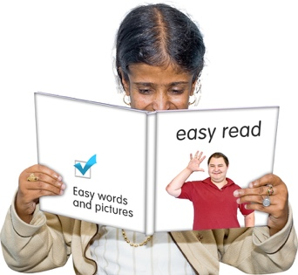
Some things you can do to make it easier are:
read it a few pages at a time
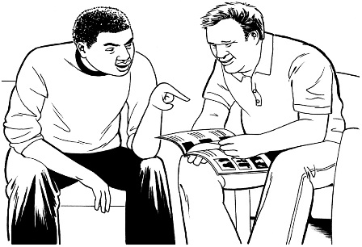
set aside some quiet time to look at it
have someone read it with you to support you to understand it.

What you will find in here

Page number:


About this document 5


Ways hate crime laws
could be changed 11
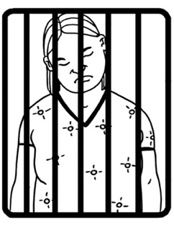

1 The sentence aggravation model 13


2 Making specific new
hate crime offences 18


3 Scottish hybrid model 25

Page number:
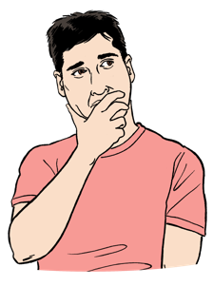

More things to think about 28


Deciding which legal model to use 39


Having 2 models together 40

Questions 42


More information 46

About this document

This Easy Read document is from Te Aka Matua o te Ture Law Commission.


In this document we will call Te Aka Matua o te Ture Law Commission the Law Commission.

Where it says we / our this means the Law Commission.

The Law Commission does research to find out how to make the laws better here in Aotearoa
New Zealand.

We are doing a review about hate crime laws.

Here review means looking at:
- how well something is working
- if anything should change.
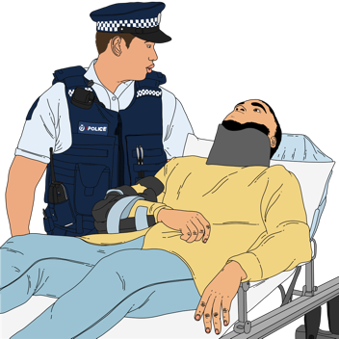

Hate crime is when the reason for a crime is hate.


Laws are rules made by the Government which people must follow.


We want to find out what people think about hate crime laws here in Aotearoa New Zealand.


We have made a document to support people to do this.

It is called the Consultation Paper.


We have also made a summary of the Consultation Paper.


A summary:
- is shorter than the main document
- tells you the main ideas.


This document is called Part 3.

Part 3 is 1 of 4 documents making up the Easy Read summary of the Consultation Paper

It tells you things to think about the hate crime laws and if they should be changed.

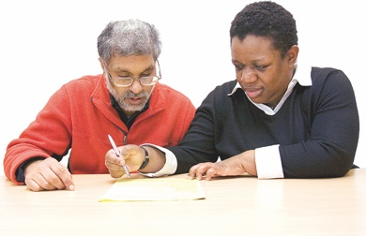
These 4 Easy Read documents will support you to make a submission.


Here a submission means the way you can tell us what you think about the hate crime laws in Aotearoa
New Zealand.


Your submissions will help us to work out what needs to change about hate crime laws.
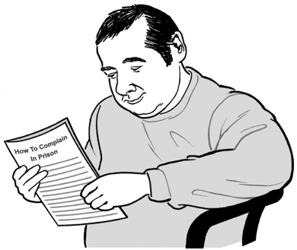

All 4 Easy Read documents have important information that will be useful when you make a submission.

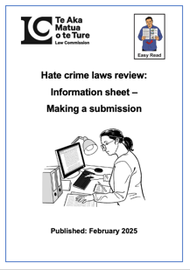
The Information Sheet tells you what you need to know including:
how to make your submission
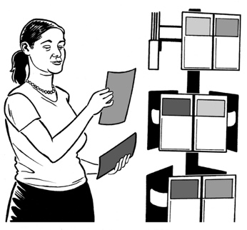
information about your privacy
how we will use the information you give us in your submission.
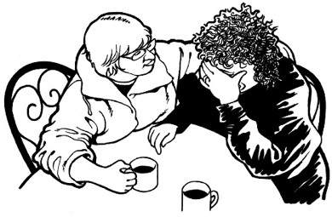
where to get support if you find making a submission about hate crime laws upsetting

where to send your submission
links to the other information about the hate crime laws review.

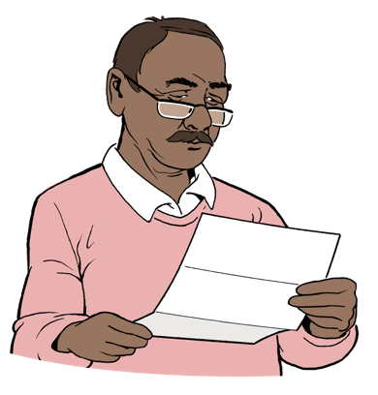
Read the Easy Read terms of reference for this review here:

www.lawcom.govt.nz/our-work/hate-crime/tab/terms-of-reference


You need to send your submission to the Law Commission by:
5pm

13 March 2025

Ways hate crime laws could be changed

There 3 legal models we could use if we find the current hate crime laws are not working.

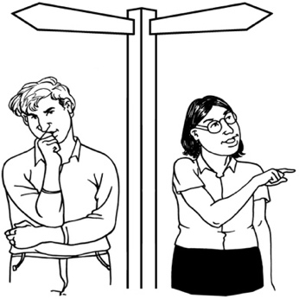
Here model means a way to do / think about something

Here a legal model is a way the law could deal with hate crime.

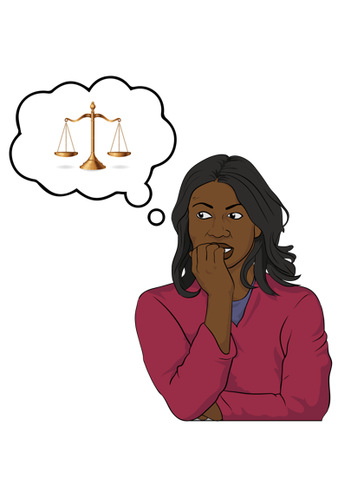
These 3 models are:
the sentence aggravation model
making specific new offences
the Scottish hybrid model.


Specific means something that relates to / is about 1 thing.


These 3 legal models are used in some other countries.


We will tell you more about these
3 models on the next pages.

The sentence aggravation model


The sentence aggravation model is being used in New Zealand now.

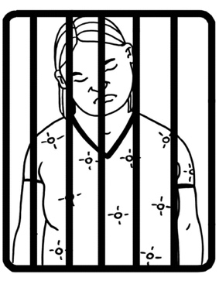
Here sentence means what a judge says should happen to someone who has committed a crime / offence.

A sentence can be something like:

going to prison
paying a fine / money.

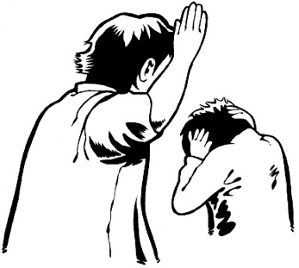
Here aggravation means making something worse.


The sentence aggravation model is also used in some other countries.


In this model when an offender has committed / done a hate crime it is included as an aggravating factor.

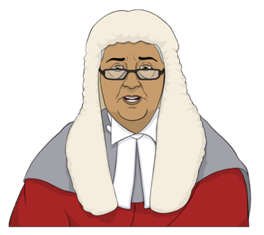
Aggravating factors are things a judge has to think about when making a decision about the sentence for an offender.

Aggravating factors can make a sentence longer.


Hate motivation is an aggravating factor.

Here hate motivation means the reason for the crime / offence is hate.

In the sentence aggravation model:

hate motivation is not part of the offence

the maximum punishment for the offence does not change
hate motivation is not included in the conviction of the offender.


Maximum means the most / biggest that something could be.


A conviction is when a person / offender:
- is charged with a crime / offence
and

- the court / judge decides that the person has committed the
crime / offence they have been charged with.


An offence is when someone has:
done something bad


and
broken the law.

An offence can also be called a crime.


A person who commits / does an offence is called an offender.

Making specific new
hate crime offences

Another model we will look at is making specific hate crime offences.

Here specific relates to hate as a motivation for a crime / offence.


This will mean hate motivation will be a main part of the offence.

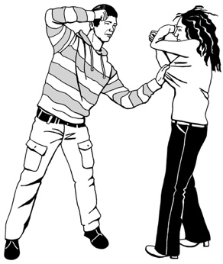
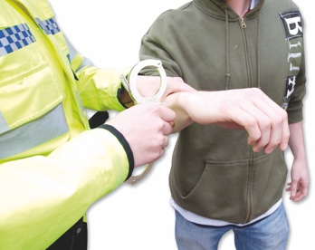
When a person is charged with a hate crime the court will have to decide that the reason for the crime is hate.

For example hate could be part of an offence like assault

Here assault is where a person hurts another person.

When hate is part of an offence it can have a higher maximum sentence.

If a new offence is made it has to:
- be very clear what the offence is
- be shown to be motivated by hate
- have its own maximum sentence.

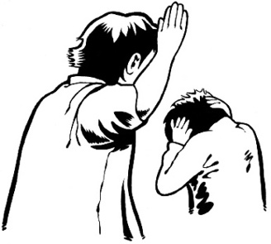
New hate crime offences will only be
about some kinds of:
- hate crimes

- characteristics.

Characteristics are things a person / group have in common.

They can be things like:
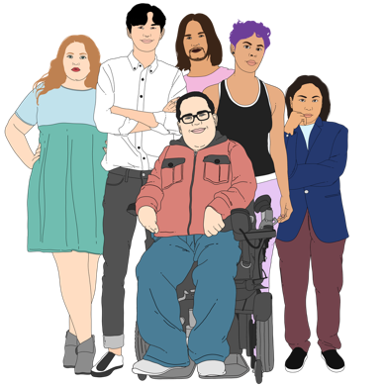
race / skin colour
religion
gender
sexuality
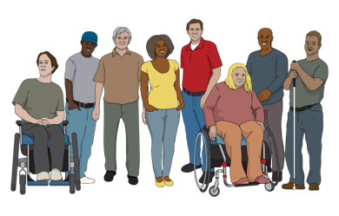
- age
- disability.


Gender is if you are:
a man
a woman
another gender like nonbinary.


Your sexuality is things like:
who you are attracted to
who you want to be in a relationship with
if you want to be in a relationship or not.



The Royal Commission of Inquiry said that there should be new hate crime offences for things like:
- hurtful language
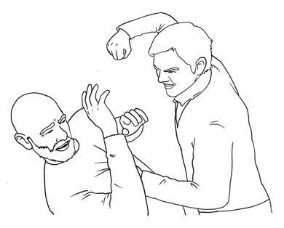
- damage to property
- assault
- setting something on fire like a building.


If the person is convicted of a hate crime / offence then the information about hate motivation:

is included in all the information / records about the crime / offence by the offender
can be reported in the media like newspapers that the crime / offence is a hate crime.


There are a lot of things we will need to think about if we decide to make new hate crime laws.


There are good things about making specific new hate offences.

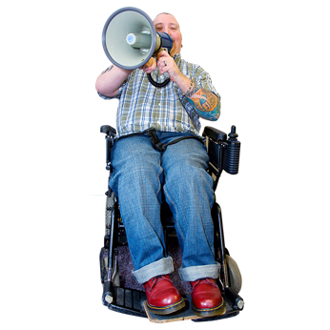
Some of the good things could be:
- tells people that hate crimes are very serious
- makes collecting information about hate crime easier
- changes how people see hate motivated crimes
- will work better for the person who has been the victim of the hate crime.

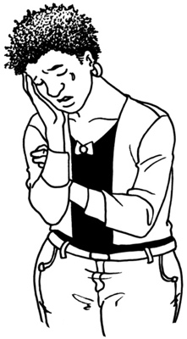
Here victim means the person / people who was / were hurt by the hate motivated crime.

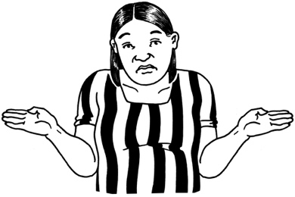
There are some things that might mean making specific hate crime offences is not the best way to address hate crime laws.
These can be things like:
not including all the kinds of hate crimes
making court processes longer.

Here processes mean the things that happen in court.

The Scottish hybrid model

Here hybrid means a mix of 2 or more kinds of legal models.

Another model we will look at using is the Scottish hybrid model.
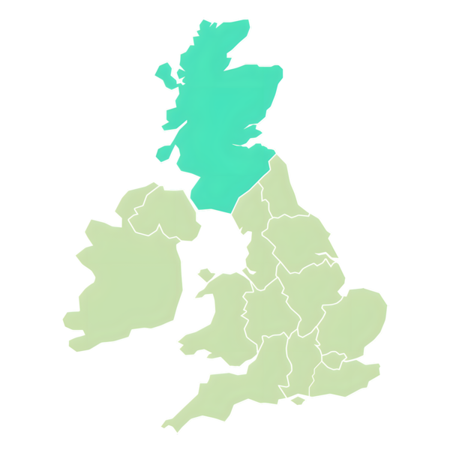

The Scottish hybrid model is used in Scotland.

This model includes hate crime in an offence when hate is the aggravating factor.

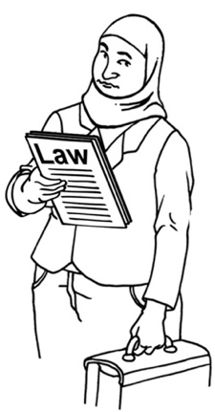
This means when the offender is in court a lawyer can say that the reason for the crime / offence is hate.
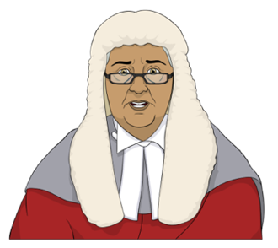
If a person is convicted then the judge will include hate when making the decision about the sentence.

In the Scottish hybrid model the maximum sentence does not change even if hate is included in the sentencing decision.

The Scottish model does not include all protected characteristics.


The Scottish hybrid model has:
- some parts that will work well

- some parts that will not work well.


There are differences between:
making specific new offences
and
the Scottish hybrid model.

The differences are that the Scottish hybrid model:


- does not change the maximum sentence for hate crimes
- covers more hate crimes
- is easier to use because it does not make a lot of new hate crime offences.

More things to think about


There are some good things about the sentence aggravation model.

These include things like:
- hate can be an aggravating factor for any offence
- it can be used for all common characteristics

each hate crime is looked at to work out how serious it is.

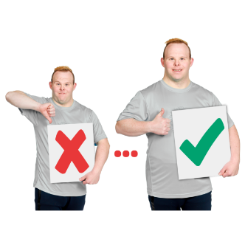
If we recommend keeping the sentence aggravation model there are still changes we can make.

Some good things about making changes to the sentence aggravation model instead of using a different model are:
it would not cost much money to change it

there will not have to be many changes made to laws about hate crimes.

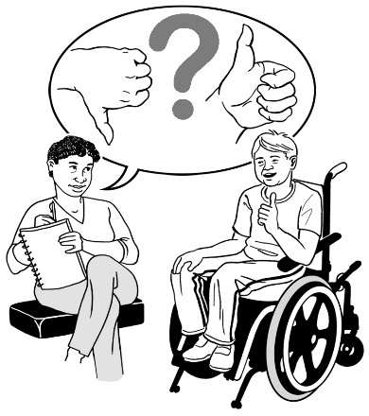
On the next pages we talk about some ways the sentence aggravation model could be changed.

We want to know what people think about these changes.

Showing that hate crime is very serious

The Law Commission might find that the sentence aggravation model does not do enough to show hate crimes are serious.

It is important that people know hate crimes:
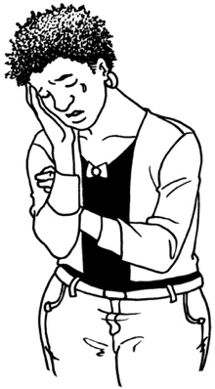
are very serious.
hurt a person / community.

Ways to make the sentence aggravation model better could include:

- making sentencing judges say that the offence is a hate crime in court so that the:
- public know it is a hate crime

- media know it is a hate crime.
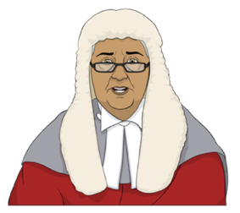
- making judges explain how the hate motivation of the offender has affected the sentence.

There may be other ways to make the sentence aggravation model better.

One way is to look to see if the maximum sentence for some offences should be changed.
It could be changed so hate crime offenders can be given sentences that are high / long enough.


Doing these things could show people how serious hate crimes are.

It might also make people stop doing hate crimes if they know they will get a big sentence if they are convicted of a hate crime.

Supporting people to report hate crime


Changing the legal model used might not be the right way to:
support people to report a hate crime
let people know how important it is to report hate crime.

A different legal model might not change all the things that stop people reporting hate crimes.

There are other ways to let people know how important it is to report hate crime including:
- making a public awareness campaign
- looking at other ways of being able to report hate crime.

Here a public awareness campaign is a way to let people know:
about hate crime

how to report hate crime.

These can be things like:
social media like Facebook / Instagram / websites
in newspapers / magazines.

Prosecuting hate crime

Prosecute is a legal word that means:
- a person is charged with doing a crime / offence
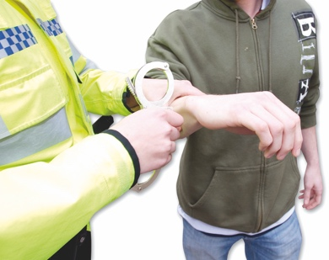
and
- a prosecutor has to prove they did the crime.

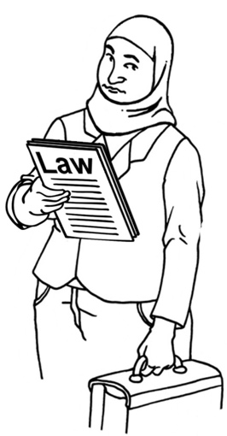
Prosecutors are lawyers who work in the court.

We might find that prosecutors need training to learn more about hate crimes.

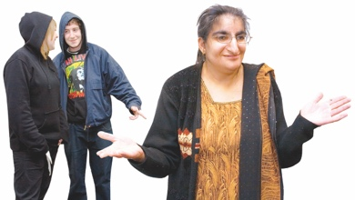
We could also recommend that prosecutors flag hate crimes to make sure a judge knows that hate is part of a crime.

Here flag means a way to let people know about something.

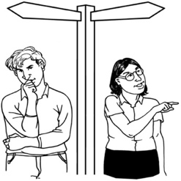
It is also important to think about ways that:
- hate is included in all the information a court has about a hate motivated crime
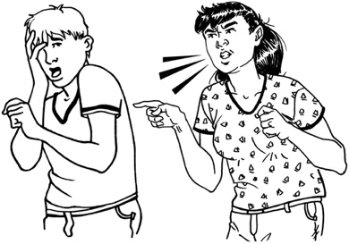
- people working on a case know that the crime is a hate motivated crime.

Having good information about hate crime

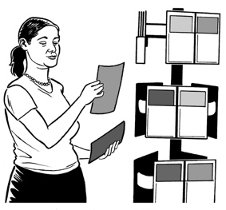
If a court has information about a hate crime it might be able to share this information with the Police.


This would assist Police to see how much hate crime there is.

Including hate as an aggravating factor
in a crime

We will need to think how hate is included as an aggravating factor in a crime / offence.


There might be a way to sort this out by changing the words in some of the current hate crime laws.

For example the law could be changed to make it clear:
that hate must be an important part of the reason for the crime
what characteristics are protected by hate crime law
that the aggravating factor can be used when the victim is not part of the group of people the offender hates.

Deciding which legal model to use

The Law Commission may find that problems with current hate crime laws cannot be addressed using the sentence aggravation model.

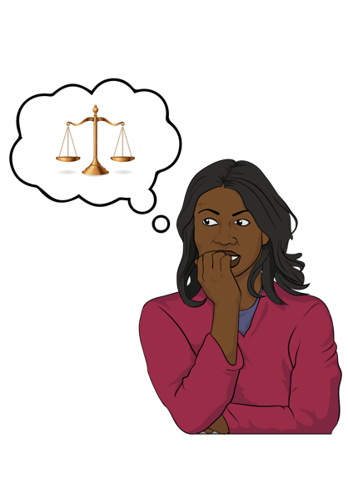
We might need to think if the other legal models will work like:
- making new hate crimes / offences
- using a different legal model like the Scottish hybrid model.


We are interested to hear what you think about this.

Having 2 models together
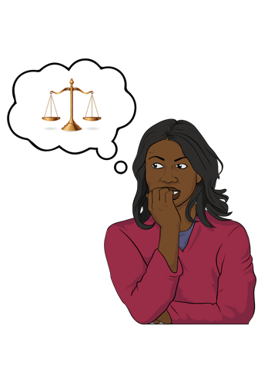

Here is the last thing you need to think about when making changes to the hate crime laws.

We could use a mix of the models.

We could keep using the sentence aggravation model with:
- making specific hate crime offences
- the Scottish hybrid model.

Using 2 models together could mean:
the law treats hate crime seriously
and
the law covers all kinds of hate crimes.

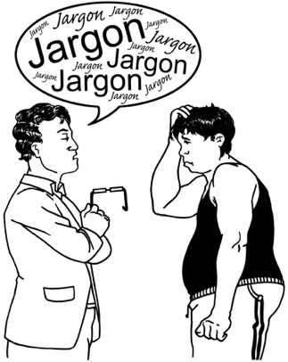
The main worry is that using a mix of models will make the hate crime laws very complicated.

Questions

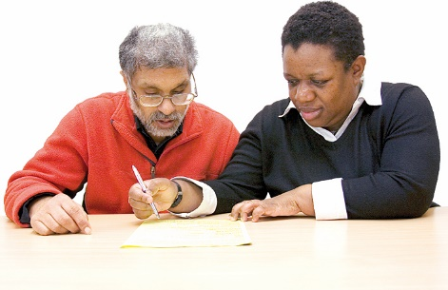
Write your answers to the questions in the boxes.

You do not have to answer all of the questions.


Do you think any problems with current hate crime law can be sorted out by changing the sentence aggravation model?

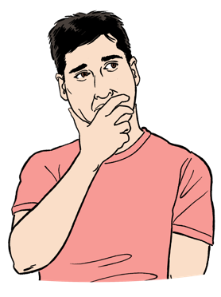
How do you think the sentence aggravation model should be changed?

What kinds of offences do you think should be specific hate crime offences?

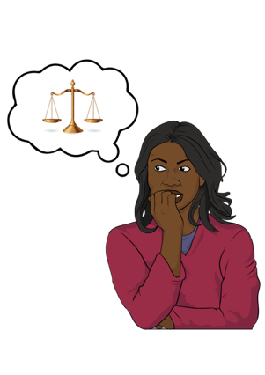
Do you think New Zealand should change to a different legal model?



Why do you think New Zealand should use a different legal model?

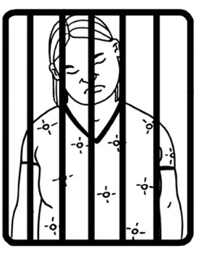
Should the sentence aggravation model be used with the Scottish hybrid model?


Should the sentence aggravation model be used with making specific hate crime offences?

More information


You can find out more information on the Law Commission website at:

www.lawcom.govt.nz



The website is not in Easy Read.

This information has been written by Te Aka Matua o te Ture Law Commission.

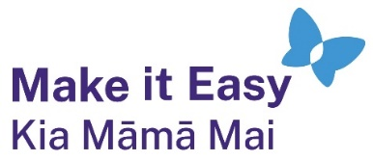
It has been translated into Easy Read by the Make it Easy Kia Māmā Mai service of People First New Zealand Ngā Tāngata Tuatahi.

The ideas in this document are not the ideas of People First New Zealand Ngā Tāngata Tuatahi.

All images used in this Easy Read document are subject to copyright rules and cannot be used without permission.


Make it Easy uses images from:


- Photosymbols

- Change Images



- Huriana Kopeke-Te Aho

- SGC Image Works


- T Wood

- Studio Rebeko.

