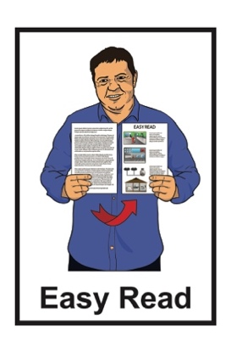

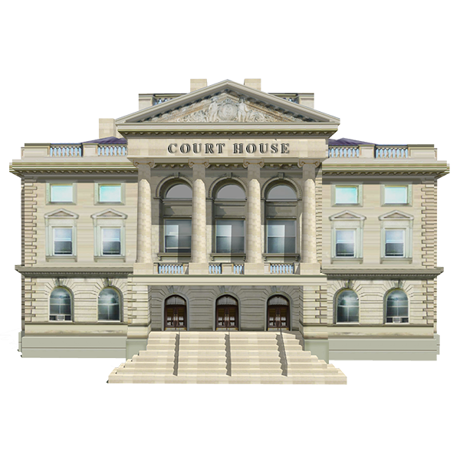Hate crime review  
terms of reference

Published: September 2024

# Before you start

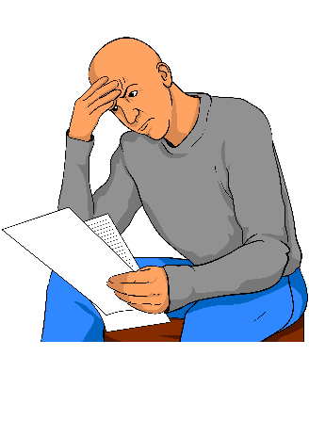

This information may upset some people when they are reading it.

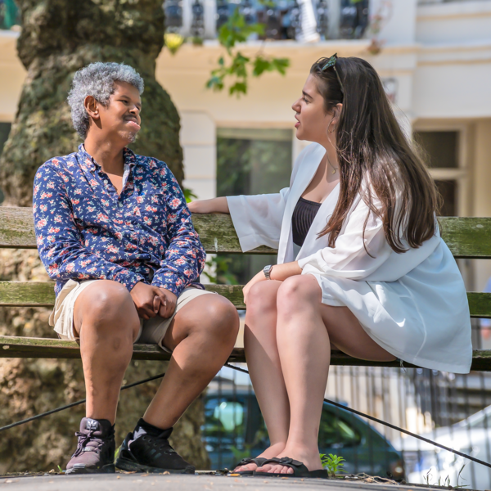If you are upset after reading this document you can talk to your:

whānau / family

friends.

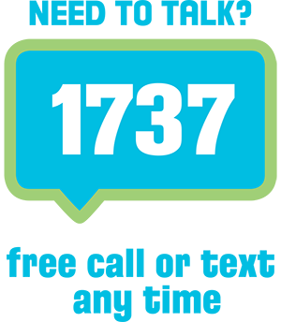You can also contact Need to Talk by:

calling 1737

texting 1737.



It does not cost any money to call / text 1737.

# What is in this document

This Easy Read document is from **Te Aka Matua o te Ture Law Commission**.



**Te Aka Matua o te Ture Law Commission** does **research** to find out how to make better laws.

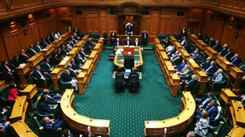It makes **recommendations** to the Government.

The Government cannot tell it what to do.

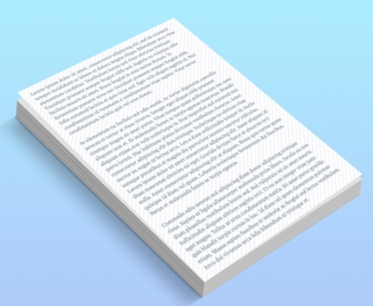

In this document we will call Te Aka Matua o te Ture Law Commission the **Law Commission**.

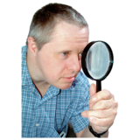**Research** is when we:

* look at what things have happened
* 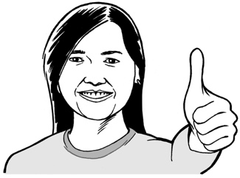try to find ways to do things better.

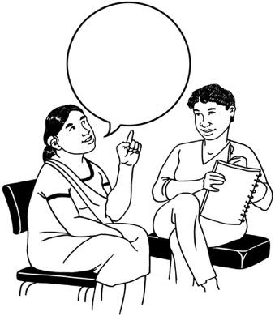

Making **recommendations** means telling someone what we think they should do.

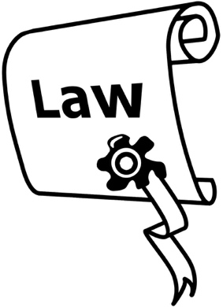

The Law Commission is doing a **review** of the laws about hate crimes.



Here **review** means looking at:

how well something is working

if anything should change.

# Hate crimes

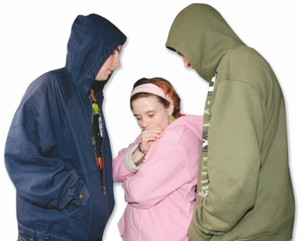

A **crime** is when someone:

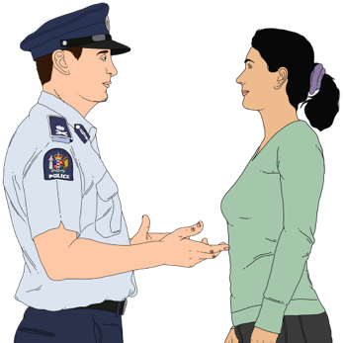does something wrong that harms others

* breaks the **law**.

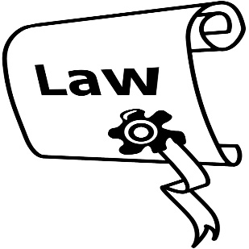**Laws** are rules made by the Government which people must follow.

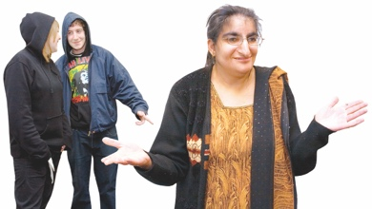A **hate crime** is when someone commits a crime against another person / group of people because of things like their:

race / skin colour

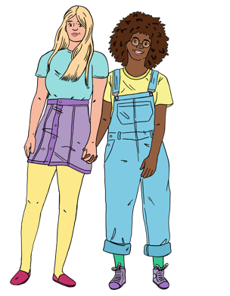religion

**gender**

**sexuality**

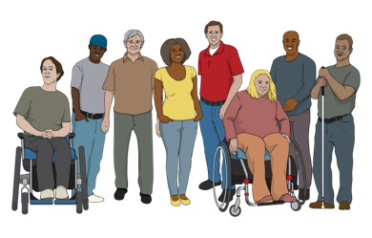age

disability.

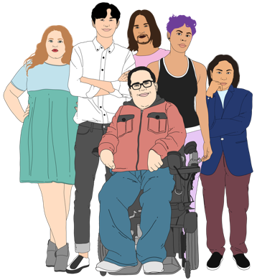**Gender** is if you are:

a man

a woman

another gender like nonbinary.

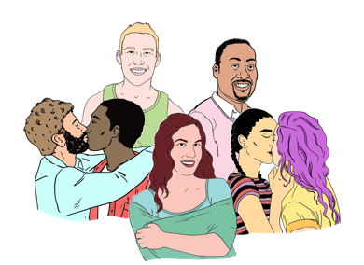Your **sexuality** is things like:

who you are attracted to

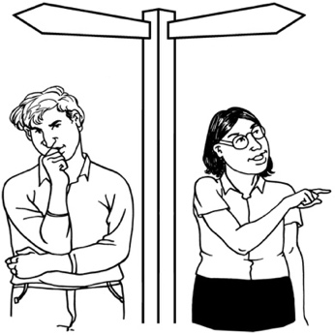who you want to be in a relationship with

if you want to be in a relationship or not.

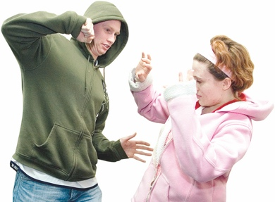

Examples of hate crimes might be:

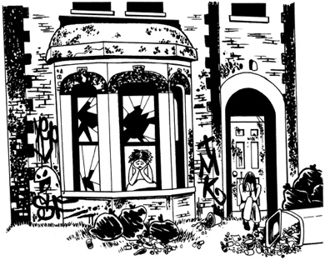someone hitting you because you are disabled

someone damaging your house because you are gay.

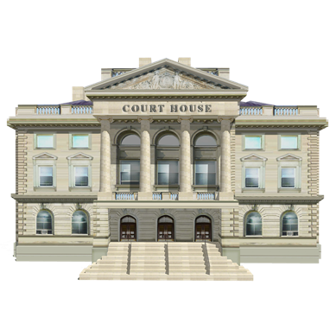If something is a hate crime it changes the **sentence** the court can give.

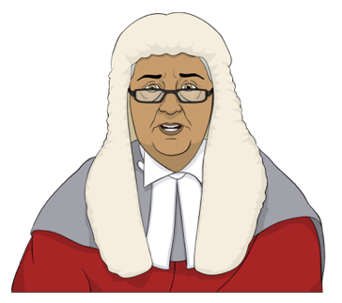

It can make the sentence higher / bigger.

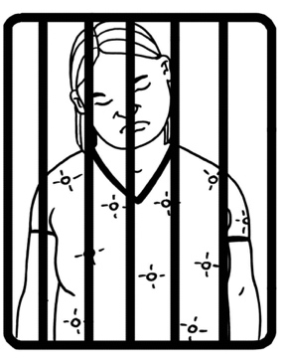**Sentence** means what a judge says should happen to someone who has committed a crime like:

going to prison

paying a fine / money.

# About the review



On 15 March 2019 a man with a gun shot a lot of people in 2 masjidain / mosques in Christchurch.

There was a **Royal Commission of Inquiry** to find out:

how this could have happened

how to stop it happening again.

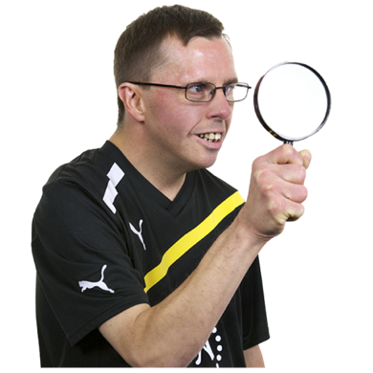

A **Royal Commission of Inquiry** is a way for the Government to look into important issues.

The Royal Commission of Inquiry said Aotearoa New Zealand should change the law so that hate crimes are treated more seriously.

The Law Commission review will look at if the laws about hate crimes:

are working

should be changed to treat hate crimes more seriously.

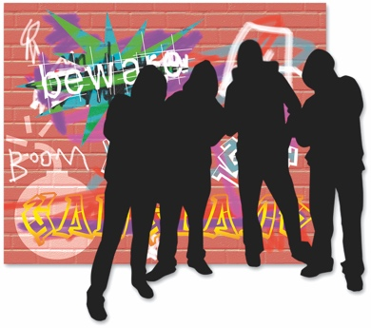

The review will also look at if there are more crimes that should be treated as hate crimes.

If the Law Commission thinks

hate crimes should be treated more seriously the review will look at:

* what hate crimes should be treated more seriously
* which groups of people should be **protected**
* what the **maximum** sentence should be.

**Protected** means kept safe.



**Maximum** means the most / biggest that something could be.

The review will **not** look at making anything that is not already a crime into a crime.

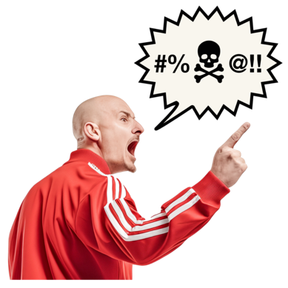This means the review will **not** look at things like:

videos people might find upsetting

**hate speech**.

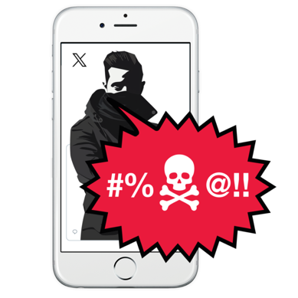

**Hate speech** means saying things that could stir up hate against a group of people.

The Law Commission will **publicly consult** about the review in early 2025.

**Publicly consult** means giving everyone a chance to tell the Law Commission what they think.

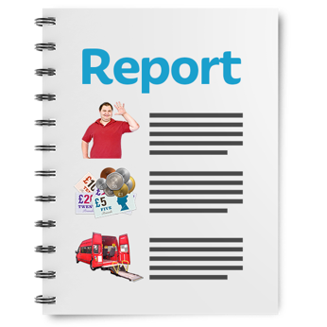

The Law Commission will write a report about what the review has found out.



The Law Commission will give its report to the Government in 2026.

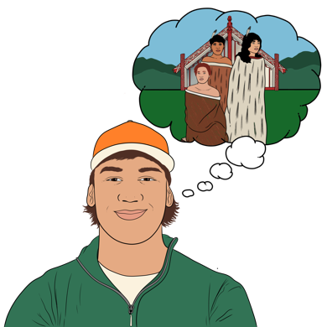When it writes the report the Law Commission will remember that **Te Ao Māori** is important.

**Te ao Māori** means the Māori world.

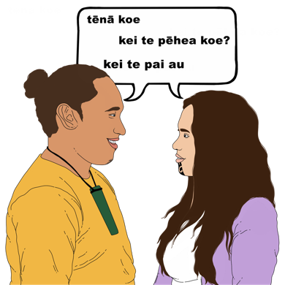

It includes things like:

language

beliefs.

The Law Commission will also remember that Aotearoa New Zealand is a **multicultural society**.

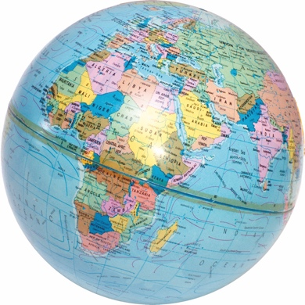A **multicultural society** means that Aotearoa New Zealand has people from a lot of different:

places in the world

**cultures**.

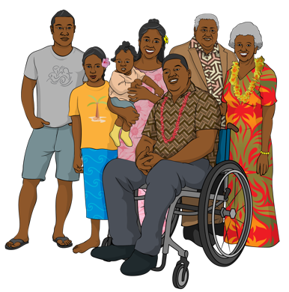

**Culture** is a way of:

thinking that a group shares

doing things as a group.

# More information



You can find out more information on the Law Commission **website** at:

[**www.lawcom.govt.nz**](http://www.lawcom.govt.nz)

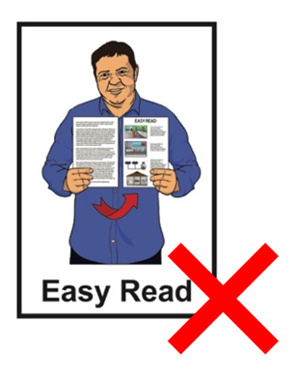

The website is **not** in Easy Read.

This information has been written by Te Aka Matua o te Ture Law Commission.

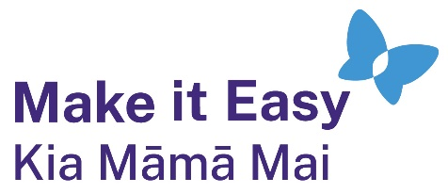It has been translated into Easy Read by the Make it Easy Kia Māmā Mai service of People First New Zealand Ngā Tāngata Tuatahi.



The ideas in this document are not the ideas of People First New Zealand Ngā Tāngata Tuatahi.

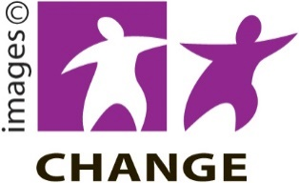Make it Easy uses images from:

* Changepeople.org

Photo SymbolsPhotosymbols.com

* SGC Image Works
* Huriana Kopeke-Te Aho
* T. Wood.

  
All images used in this Easy Read document are subject to copyright rules and cannot be used without permission.